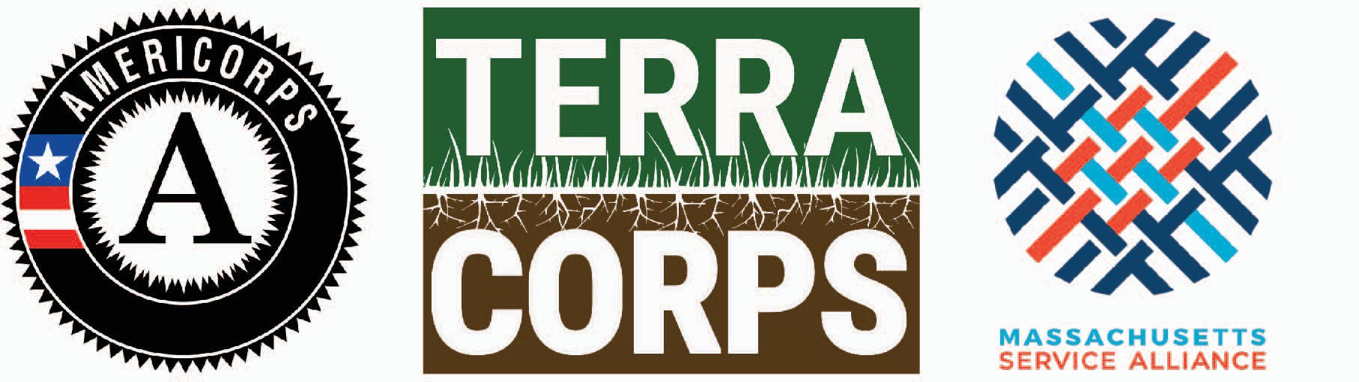

TerraCorps 2020-2021 Three-Quarter Term Program
Application Form for Returning MA Service Sites
Review the Service Site Application Packet in advance of applying to become a TerraCorps Service Site to see process updates and new financial information. Applications from Returning Service Sites will be accepted on a rolling basis. All organizations will be informed of selection decisions by early November. Member recruitment will also kick off in early November. Contact Lianna Lee, Chief Program Officer (llee@terracorps.org) with any questions.

Service Site Information

Organization:
Name of individual completing form:
Website:
Address:
Number of staff working at this organization:
Organizational budget* from most recent audited statement:
TerraCorps offers a sliding scale fee model to accommodate a range of organizational capacities.
___ Partnered Service Sites: Are you interested in applying in partnership with another Service Site to co-host one Member? Please respond “Yes” or “No.” If you select "yes" to this question, please provide the name of the other hosting organization:

Service Site Eligibility
TerraCorps Service Sites must meet certain eligibility requirements. Please read the Service Site Application Packet and complete the following questions by writing “Yes” or “No” next to each one.

___ Is your organization a non-profit 501(c)3 community-based organization (or fiscally sponsored by a 501 (c) 3) in MA with a mission or major programs focused on land conservation, land access, sustainable agriculture, or sustainable land use.

___ Does your organization (or lead organization if sharing a Member) have at least one full-time staff member, a part-time staff member, or a board of director-level equivalent volunteer who can oversee the supervision, trainings, and mentoring of a TerraCorps Member? Note: necessary for lead service sites.

___ Can your organization provide site-specific professional office space for your Member (i.e. not virtual or home office, not isolated from staff or volunteers)?

___ Can your organization provide special equipment needed for your TerraCorps Members to carry out their service activities? Please place an “x” in either the “individual” or “shared” column in the chart below.

Individual Shared
Office Space
Telephone
Voicemail
Printer
Computer
Internet Access
E-Mail Account

___ Does your organization have liability insurance that would cover your TerraCorps Member(s) at your service site and in the field? If selected, proof of insurance will be required.

___ Can your organization pay the administrative fees and meet the deadlines outlined in the Service Site Application Packet?

___ Can your organization pay service-related costs associated with Member travel, training, supplies, and equipment?

___ Does your organization have a board-adopted non-discrimination policy that offers services without regard to age, religion, disability, political affiliation, veteran status, gender identity, sexual orientation, race, ethnicity, or national origin? If selected, a copy of your policy will be required.

___ Does your organization have an established and board-adopted sexual harassment policy that will apply to your TerraCorps Members? If selected, a copy of your policy will be required.
___ Does your organization provide a drug-free workplace?

___ Is your office space ADA accessible? While TerraCorps does not require Service Sites to be fully ADA accessible, we ask that you identify the accessibility of your office space so we can better assist applicants of varying abilities. Please respond either: “Yes,” “somewhat,” or “No.” If you respond "somewhat" or "no," please share additional details:

___ Are you willing to make reasonable accommodations for Members of varying abilities?

Service Site Mission & Vision

In three to four sentences, please share your main motivation for reapplying to be a TerraCorps Service Site for the 2020-2021 program year.

- TerraCorps’ vision is to create a future where land is the foundation of health and well-being for ALL people in EVERY community. As a current Service Site, we feel your organization’s mission, vision, and/ or goals align with TerraCorps’. Please provide one to two examples of how your recent TerraCorps Members' service has promoted our shared values (i.e. increased access for historically marginalized groups, expanded benefits or opportunities for individuals beyond your base constituency, promoted access to land for people of varying abilities, etc.)

Positions Requested
- How many Members would you like to have serve at your organization, and in which TerraCorps positions? Note: You may request more than one Member for each position. We feel it is important for Members to have peer-support and opportunities for collaboration. Service site applicants that can accommodate at least two Members MAY be given priority over organizations applying for only one.

___ Regional Collaboration Coordinator
___ Community Engagement Coordinator
___ Land Stewardship Coordinator
___ Youth Education Coordinator
___ Sustainable Agriculture Coordinator

**On occasion, we support organizations applying to host a single Member in a split coordinator position (e.g. Community Engagement/ Youth Education Coordinator). If interested, please indicate the desired split position here:

Capacity Building Needs and Projects
One major focus of TerraCorps Members’ service is on building capacity through their service projects. Capacity building is defined by AmeriCorps as a set of activities that expand the scale/reach, efficiency, or effectiveness of programs and organizations. These activities achieve lasting positive outcomes for the communities served by AmeriCorps programs.

What pressing need(s) for land conservation, land access, or sustainable land use in your service area will be addressed through TerraCorps Member's capacity building activities in the 2020-2021 program year? (200 – 400 words)

- For each position requested, briefly describe one hypothetical capacity building project that you intend for your Member(s) to carry out next year. For each project, describe the primary need addressed, goal(s), and partner(s) if applicable (150 – 200 words). Note: We recognize these projects may change based on Member interests, skills, and other unknowns.

If you have additional project ideas that you plan to explore, please list them here.

Member Recruitment and Training
We believe one of the greatest benefits of a service year is the professional development opportunities that Members receive. TerraCorps provides opportunities for training and professional development throughout the year. We also expect Service Sites to invest in Member professional growth and development. We expect Service Sites to allocate approximately 10% of their Member’s time for mentoring, skill building, and general professional development (on or off-site) and require that Service Sites put aside $150 per Member for training each year.

Please share what professional development opportunities you have offered to your current TerraCorps Members this year, and how you intend to incorporate professional development opportunities in the 2020-2021 service year.

- Past experience shows that strong local recruitment efforts play a huge role in finding promising applicants for AmeriCorps positions. Please share 4 things your organization will do in your local recruitment efforts to get the word out to your community and stakeholders.

Service Site & Supervisor Changes
Service Sites and Supervisors have primary responsibility for training AmeriCorps Member(s) and overseeing their service activities, including timekeeping and monthly reporting. (See full description of Supervisor responsibilities in the Service Site Application Packet.)

Please include the following information for any returning staff member planning to supervise a TerraCorps Member:

  - Returning Supervisor Name:
  - E-mail:
  - TerraCorps Position they will supervise:

- Returning Supervisor Name:
- E-mail:
- TerraCorps Position they will supervise:

- Returning Supervisor Name:
- E-mail:
- TerraCorps Position they will supervise:

If you are planning significant changes for hosting Members (e.g. organizational staffing and member supervisor(s), office location, member training, focus for the member’s activities, etc.), please describe them here:

- Include the following information for any new staff assigned to be a Service Site Supervisor:

  - New Supervisor Name:
  - Number of hours per week this person works for your organization:
  - Briefly describe the person’s position in your organization/agency:

  - Attach Supervisor Resume

- New Supervisor Name:
- Number of hours per week this person works for your organization:
- Briefly describe the person’s position in your organization/agency:

- Attach Supervisor Resume

- Each year we ask Service Site staff to assist in trainings for TerraCorps Members. This year we are looking to expand the number and type of trainings we can offer. Are any staff at your organization willing to provide a training for members, either in person at orientation or as a remote webinar throughout the year? If so, please list the name of the staff and the training topic below. Thank you for your support!

Staff member willing to provide training Training topic

1.

2.

3.

~~~~~~~~~~~~~~~~~~~~~~~~~~~~~~~~~~~~
Please e-mail your completed application along with any additional attachments to admin@terracorps.org.

Thank you for your time.

