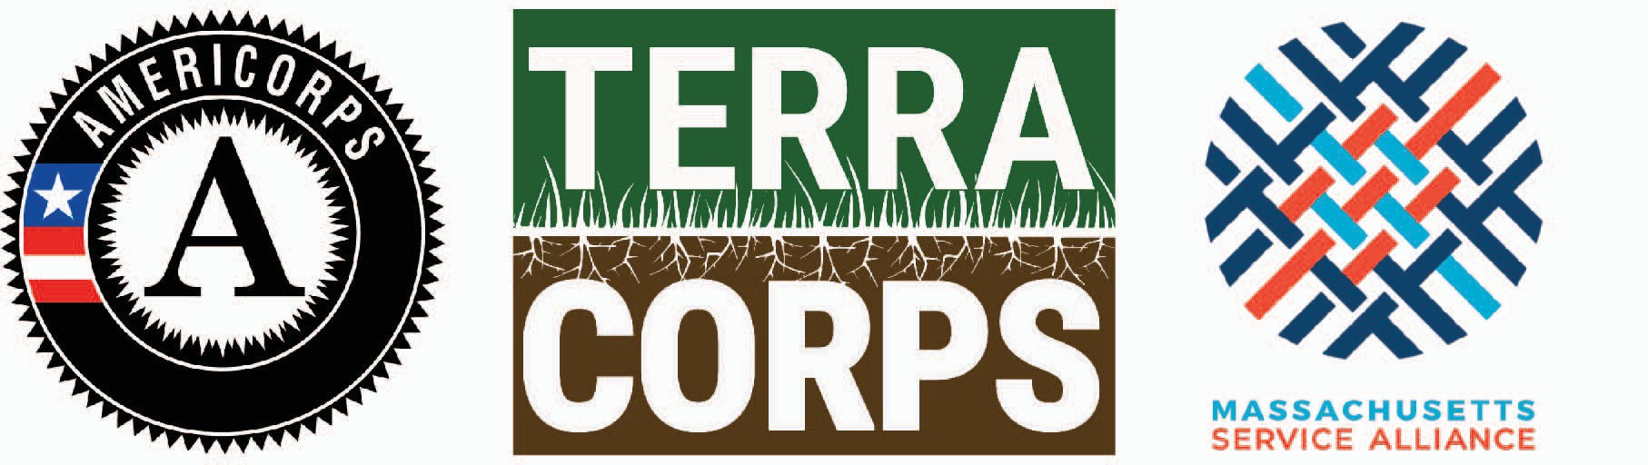

TerraCorps 2020-2021 Three-Quarter Term Program
Application Form for New Massachusetts Service Sites
Review the Service Site Application Packet in advance of applying to become a TerraCorps Service Site. Applications from New Massachusetts Service Sites will be accepted on a rolling basis. All organizations will be informed of selection decisions by early November. Member recruitment will also kick off in early November. Contact Lianna Lee, Chief Program Officer (llee@terracorps.org) with questions.

Service Site Information

Organization:
Website:
Address:
Name of individual completing form:
Job Title:
Phone:
E-mail:
Number of staff working at this organization:
Organizational budget* from most recent audited statement:
TerraCorps offers a sliding scale fee model to accommodate a range of organizational capacities.
___ Partnered Service Sites: Are you interested in applying in partnership with another organization to co-host a Member? Please respond “Yes” or “No.” If you select "yes" to this question, please provide the name of the other hosting organization:

Service Site Eligibility
TerraCorps Service Sites must meet certain eligibility requirements. Please read the Service Site Application Packet and complete the following questions by writing “Yes” or “No” next to each one.

___ Is your organization a non-profit 501(c)3 community-based organization (or fiscally sponsored by a 501 (c) 3) in MA with a mission or major programs focused on land conservation, land access, sustainable agriculture, or sustainable land use?

___ Does your organization (or lead organization if sharing a Member) have at least one full-time staff member, a part-time staff member, or a board of director-level equivalent volunteer who can oversee the supervision, trainings, and mentoring of a TerraCorps Member? Note: necessary for lead service sites.

___ Can your organization provide site-specific professional office space for your Member(s) (i.e. not virtual or home office, not isolated from staff or volunteers)?

___ Can your organization provide special equipment needed for your TerraCorps Member(s) to carry out their service activities? Please place an “x” in either the “individual” or “shared” column in the chart below.

Individual Shared
Office Space
Telephone
Voicemail
Printer
Computer
Internet Access
E-Mail Account

___ Does your organization have liability insurance that would cover your TerraCorps Member(s) at your Service Site and in the field? If selected, proof of insurance will be required.

___ Can your organization pay the administrative fees and meet the deadlines outlined in the Service Site Application Packet?

___ Can your organization pay service-related costs associated with Member travel, training, supplies, and equipment?

___ Does your organization have a board-adopted non-discrimination policy that offers services without regard to age, religion, disability, political affiliation, veteran status, gender identity, sexual orientation, race, ethnicity, or national origin? If selected, a copy of your policy will be required.

___ Does your organization have an established and board-adopted sexual harassment policy that will apply to your TerraCorps Member(s)? If selected, a copy of your policy will be required.
___ Does your organization provide a drug-free workplace?

___ Is your office space ADA accessible? While TerraCorps does not require Service Sites to be fully ADA accessible, we ask that you identify the accessibility of your office space so we can better assist applicants of varying abilities. Please respond either: “Yes,” “Somewhat,” or “No.” If you respond “Somewhat" or "No," please share additional details:

___ Are you willing to make reasonable accommodations for Members of varying abilities?

Service Site Mission & Vision

- Organizational Background: Write a one to two paragraph description of your organization’s background. Include the mission and the communities you serve. (Please also include information for partnered Service Site if applicable).

- TerraCorps works to create a future where land is the foundation of health and well-being for all people in every community. What practices does your organization have that increase inclusion and empowerment of people and communities that have historically been marginalized relative to land conservation and land access?

- What is one of your organization’s greatest accomplishments relative to equitable land access and conservation work in your community/region? Please share a recent example (within the last 1-5 years).

Positions Requested
Members can serve in one of five different coordinator positions through our program. Organizations interested in hosting Members decide which positions they would like to host based on the projects a Member would take on during the service year. For more information about each position, visit the AmeriCorps Program Page of our website.

- How many Members would you like to have serve at your organization, and in which TerraCorps positions? Note: You may request more than one Member for each position. We feel it is important for Members to have peer-support and opportunities for collaboration. Organizations applying to host at least two Members MAY be given priority over organizations applying for only one.

___ Regional Collaboration Coordinator
___ Community Engagement Coordinator
___ Land Stewardship Coordinator
___ Youth Education Coordinator
___ Sustainable Agriculture Coordinator

4a) On occasion, we support organizations applying to host a single Member in a split coordinator position (e.g. Community Engagement/ Youth Education Coordinator). If interested, please indicate the desired split position here:

4b) If you indicated on page 1 that you plan to co-host a Member with another organization, please specify which position(s) you will co-host here:

Capacity Building Needs and Projects
One major focus of TerraCorps Members’ service is on building capacity through their projects. Capacity building is defined by AmeriCorps as a set of activities that expand the scale/reach, efficiency, or effectiveness of programs and organizations. These activities achieve lasting positive outcomes for the communities served by AmeriCorps programs.

What pressing need(s) for land conservation, land access, or sustainable land use in your service area will be addressed through TerraCorps Member's capacity building activities? (200 – 300 words)

- For each position requested, briefly describe one hypothetical capacity building project that you intend for your Member to carry out next year. For each project, describe the primary need addressed, goal(s), and partner(s) if applicable (150 – 200 words). Note: We recognize these projects may change based on Member interests, skills, and other unknowns.

If you have additional project ideas that you plan to explore, please list them here.

We see opportunities for Members to educate, train, and engage volunteers and community members as important elements of their service. Please respond to the questions below to share how serving with your organization would allow Members to be involved in these activities.

Training and Volunteer Engagement

- One of our program objectives is for Members to train and educate individuals on environmental awareness and stewardship topics (land conservation and stewardship, gardening/farming, natural history, ecological systems, sustainability practices, etc.). What opportunities will your Member(s) have to do this (please describe audience type and themes)? (150 – 200 words).

How will you encourage and facilitate opportunities for your Member(s) to engage with your organization’s long-term volunteers in meaningful ways? (50 – 150 words).

Member Recruitment and Training
We believe one of the greatest benefits of a service year is the professional development opportunities that Members receive. TerraCorps provides opportunities for training and professional development throughout the year. We also expect Service Sites to invest in Member professional growth and development by allocating approximately 10% of their Member’s time for mentoring, skill building, and general professional development (on or off-site). We also require that Service Sites put aside $150 per Member for training each year.

Please describe the professional development opportunities that you will provide for your Member(s) to carry out their service activities. If outside expertise is needed, what training resources might you engage? (50-150 words)

- In addition to TerraCorps' state and national recruitment, Service Sites are responsible for local recruitment and for applicant interviews and selection. Past experience shows that strong local recruitment efforts produce better experiences for Members and Service Sites in these ways: housing availability, familiarity with locale, connections to local groups and

networks. Do you have capacity to be an active partner in this process? What will your organization do to lead local Member recruitment efforts?

Service Site & Supervisor References
Service Sites and Supervisors have primary responsibility for training AmeriCorps Member(s) and overseeing their service activities, including timekeeping and monthly reporting. (See full description of responsibilities in the Service Site Application Packet.) After the first 1 – 2 months, when Members have been oriented and trained, Supervisors will plan to meet with their Member for at least one hour each week for ongoing guidance and mentoring. Anticipate committing roughly 8% of a full- time equivalent staff position for one member.

Please include the following information for each staff person who will be supervising a TerraCorps Member:

- Supervisor Name:
- Number of hours per week this person works for your organization:
- Briefly describe the person’s position in your organization/agency:

- Include Supervisor Resume

- Supervisor Name:
- Number of hours per week this person works for your organization:
- Briefly describe the person’s position in your organization/agency:

- Include Supervisor Resume

- Supervisor Name:
- Number of hours per week this person works for your organization:
- Briefly describe the person’s position in your organization/agency:

- Include Supervisor Resume

Please provide information for two organizations or agencies that you work with whom we can contact as a professional reference to confirm the following:

- Your organization provides a healthy work environment for its staff and volunteers
- Your organization performs work to the satisfaction of partnering groups or individuals
- Your organization can fulfill commitments and administrative reporting obligations

- Name of Individual:
Organization:
Telephone Number:
Email:

- Name of Individual:
Organization:
Telephone Number:
Email:

- Each year we ask Service Site staff to assist in trainings for TerraCorps Members. Are any staff at your organization willing to provide a training for Members, either in person at orientation or as a remote webinar throughout the year? If so, please list the name of the staff and the training topic below. Thank you for your support!

Staff member willing to provide training Training topic

1.

2.

3.

~~~~~~~~~~~~~~~~~~~~~~~~~~~~~~~~~~~~
Please e-mail your completed application along with any additional attachments to admin@terracorps.org.

Thank you for your time.

